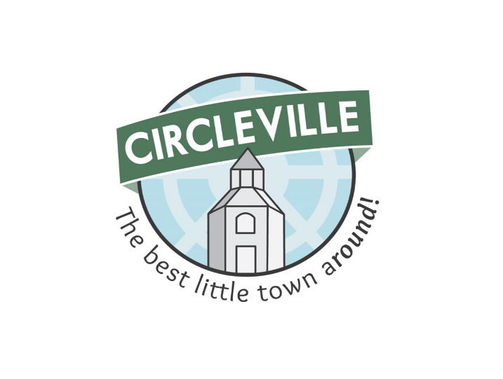
City of Circleville Fall Leaf Collection


Fall leaf collection in the City of Circleville begins Monday, November 10th, and will be collected through Wednesday, December 31st. Efforts by City of Circleville residents to deliver bagged leaves to the newly located City Garage, 150 Highland Ave., (access from N. Scioto St. off York St.) will be greatly appreciated. Please remember to dump bags, do not leave the leaves bagged. Deliveries will be accepted from 8:00 a.m. to 4:00 p.m., Monday through Friday, except for city observed holidays which are November 27th and 28th and December 24th through the 26th. For residents not able to deliver to our City Garage, bagged leaves may also be placed on the curb for pick up.

The City offers the following tips for your fall leaf collection in order to prevent stormwater pollution:

□ Place leaves ONLY between the grassy area and curb, not in the street.
□ Place leaves only for collection, no brush or other debris, as they will not be collected.
□ Park cars away from leaf piles.
□ Keep Leaves away from street storm drains. Leaves flow into the storm sewer and cause blockages and street flooding. Too much decomposing organic waste adds excess nutrients into our streams and lakes, some of which can lead to algae blooms which can be harmful to humans and pets.

We will pick up leaves throughout the remainder of the year. If you have any questions regarding leaf collection, please contact the Service Department at 740-477-8224.

